**Problem Statement**:

You work for XYZ Corporation. Their application requires a database service that can store data which can be retrieved if required. Implement suitable service for the same. While migrating, you are asked to perform the following tasks:

1. Create a Redshift data warehouse.

2. Using the query editor:

a. Load some data

b. Query the data

**Procedure: -**

* Search for redshift and use **Try Redshift serverless free trial** to avoid charges. Let everything be default and click on **Save configuration**.
* Once the configuration is done, we need to click on create work group.

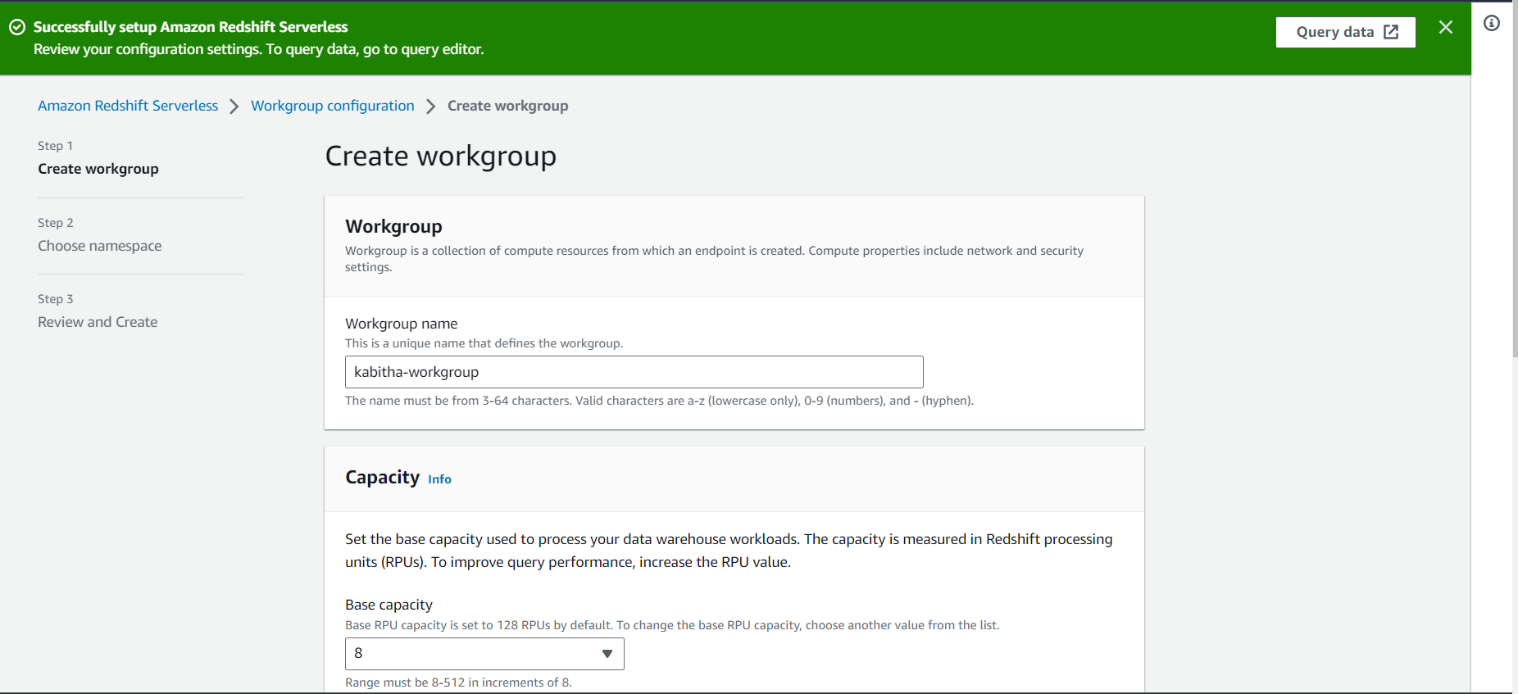

* Let everything be default and click on next.

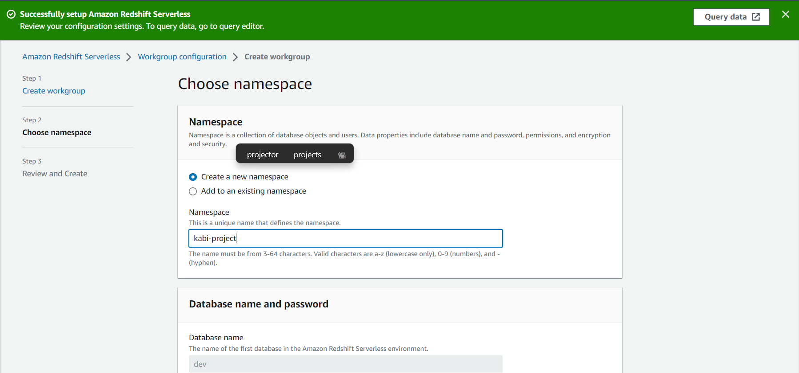

* Let everything be default and click on next.
* Review everything and create workgroup.

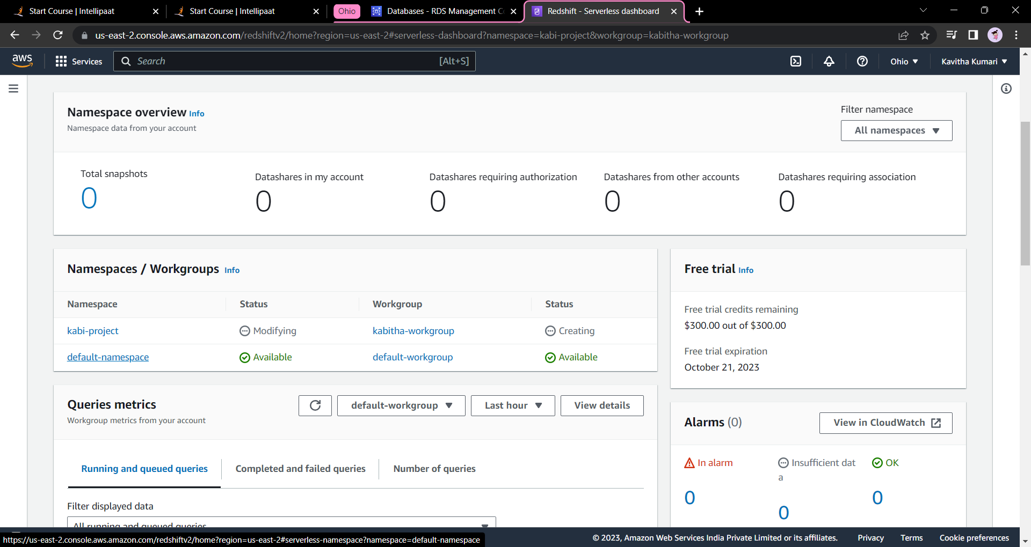

* We already had the default workgroup. Click ono the default namespaces

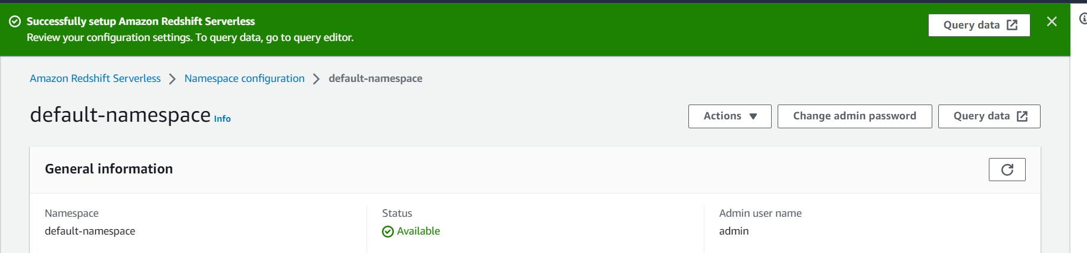

* Click on Query data.

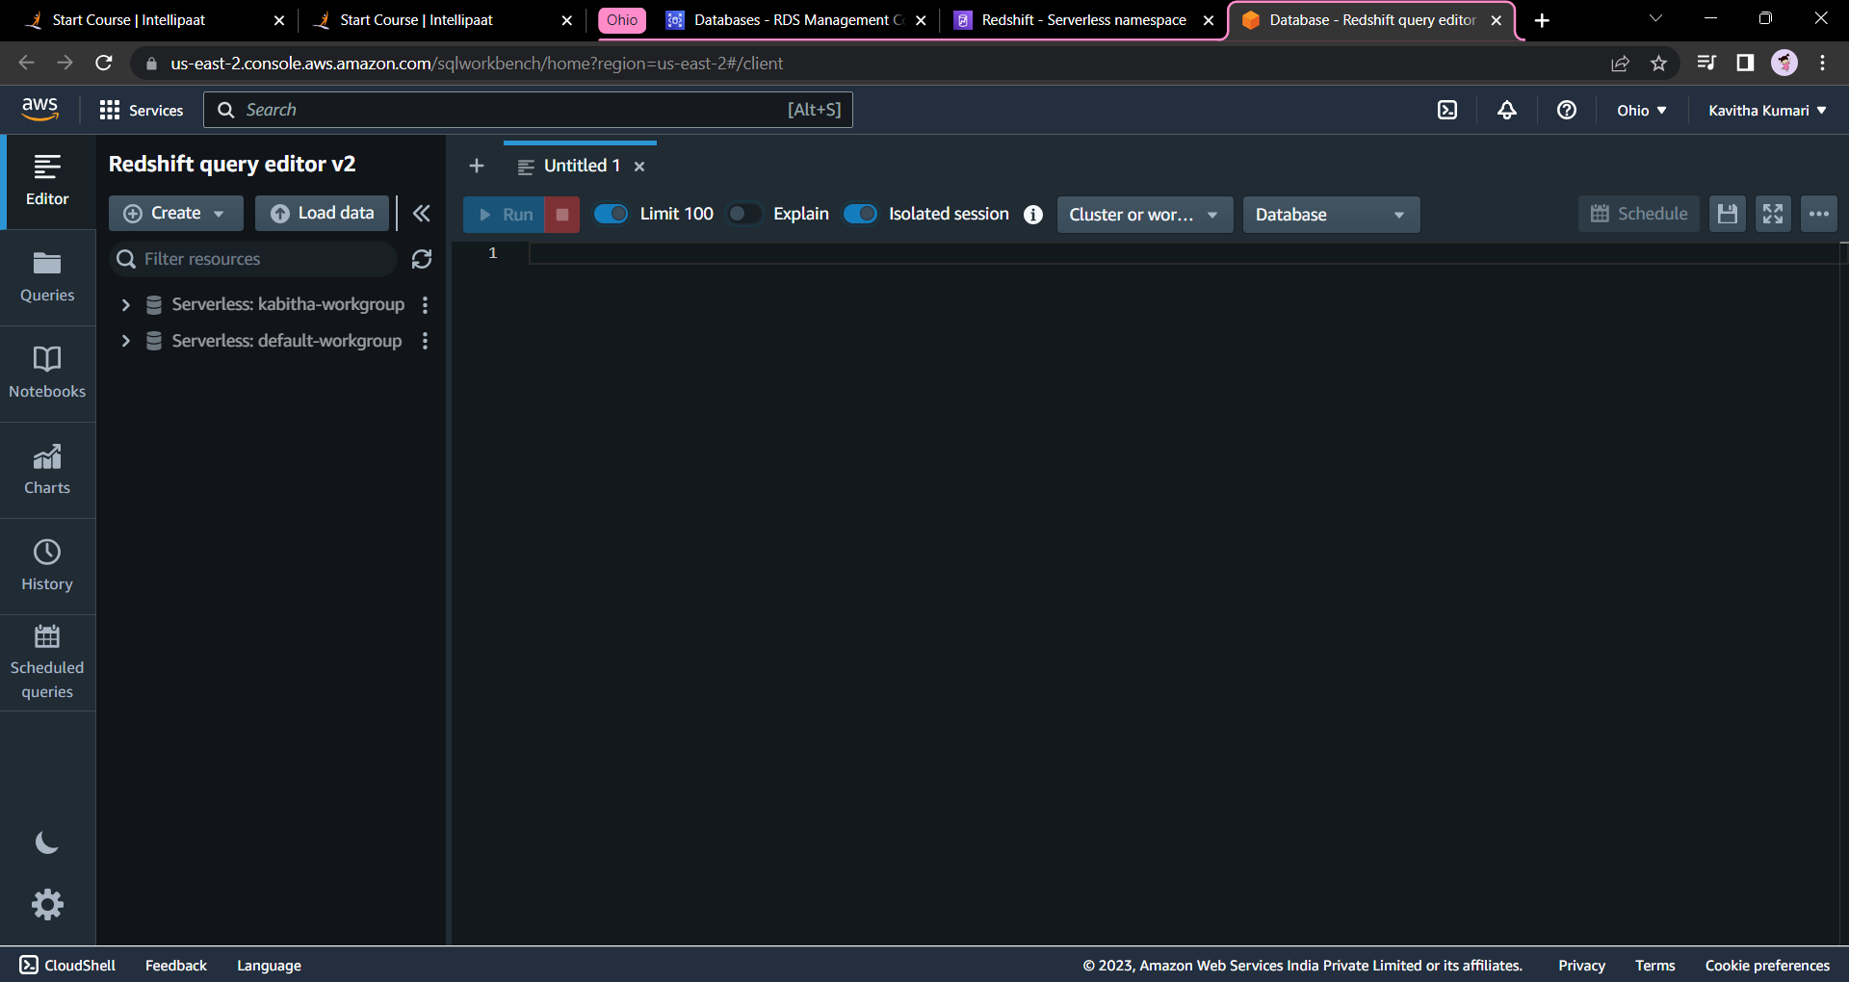

* Click on default work group and click on create connection.
* Now we have to create an IAM role in order to access the data from the s3.
* Goto IAM and click on roles then create roles.

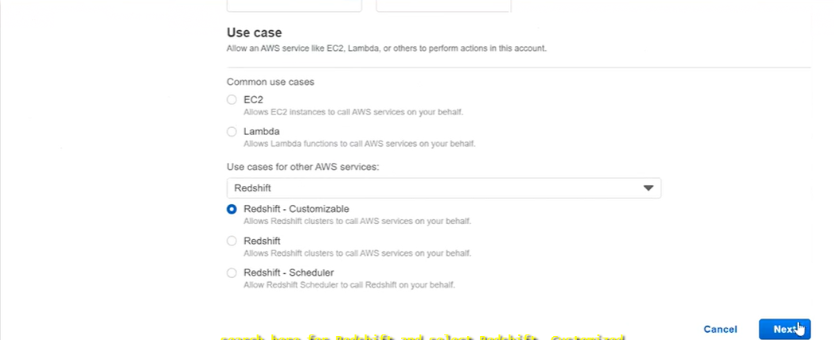

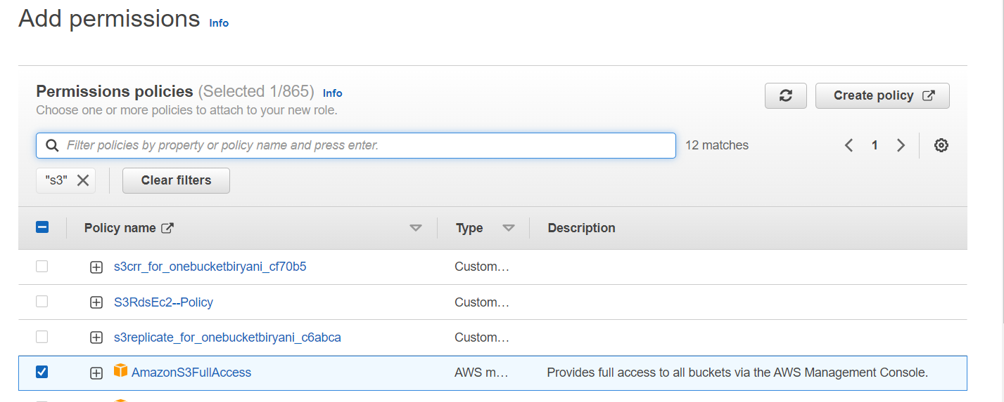

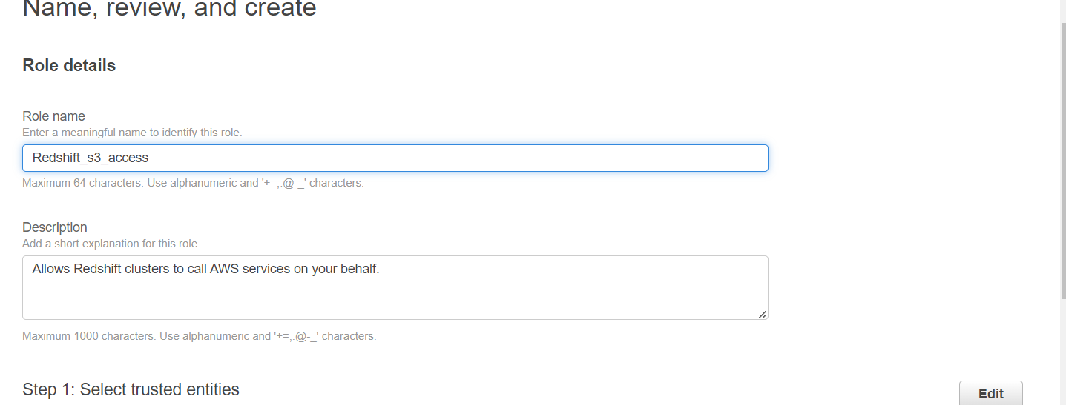

* Then create a role.
* Now in the default namesspaces goto to **security and encryption** and **manage IAM roles** and **associated IAM roles.** Then select the IAM role which we created.

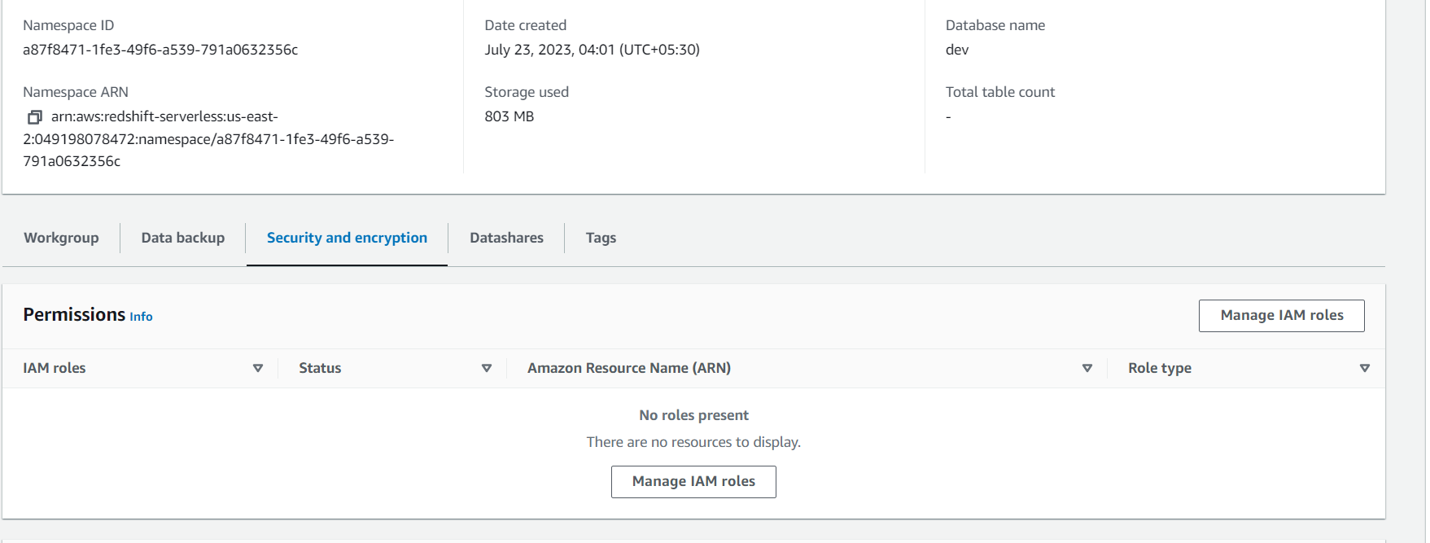

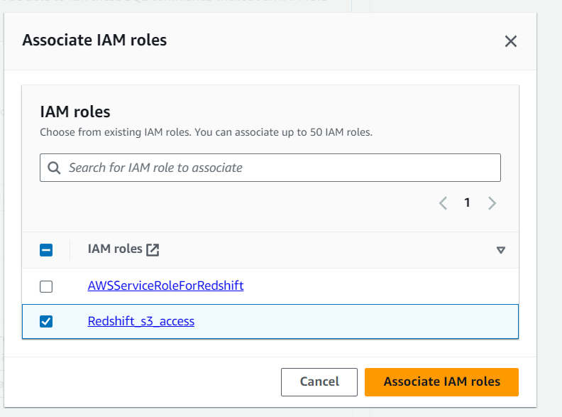

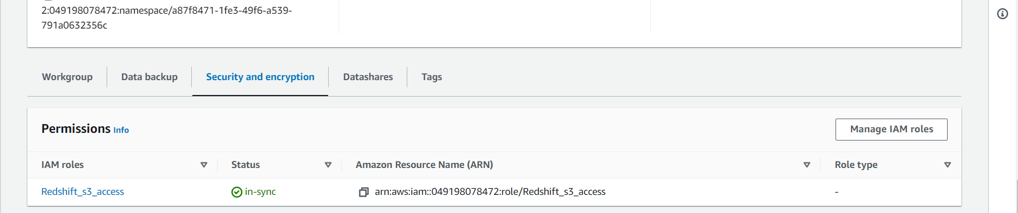

* 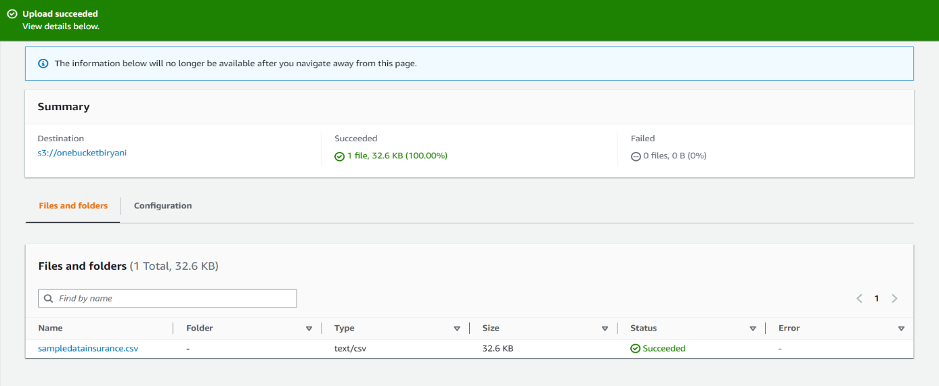Now I have uploaded a CSV type of file in the s3.
* Now in the serverless redshift click on load data and click **browse s3**

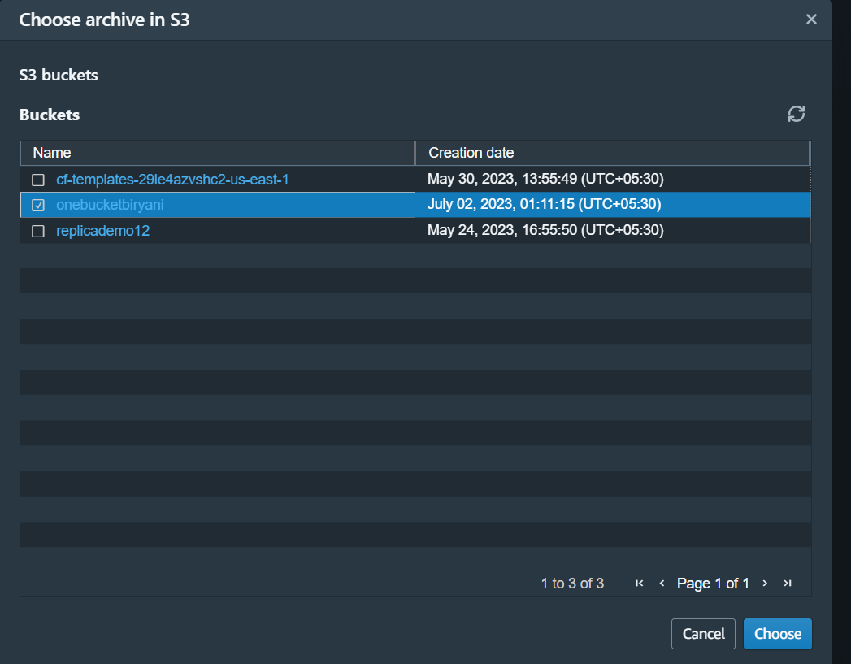

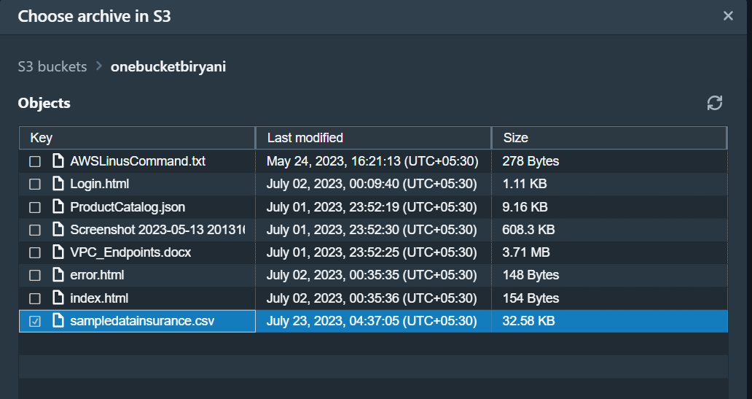

* Click on choose and next. Then click on **choose an IAM role.**
* Choose **load new table** and select the schema as **public**  and give the name to the table as **kabi-table.**

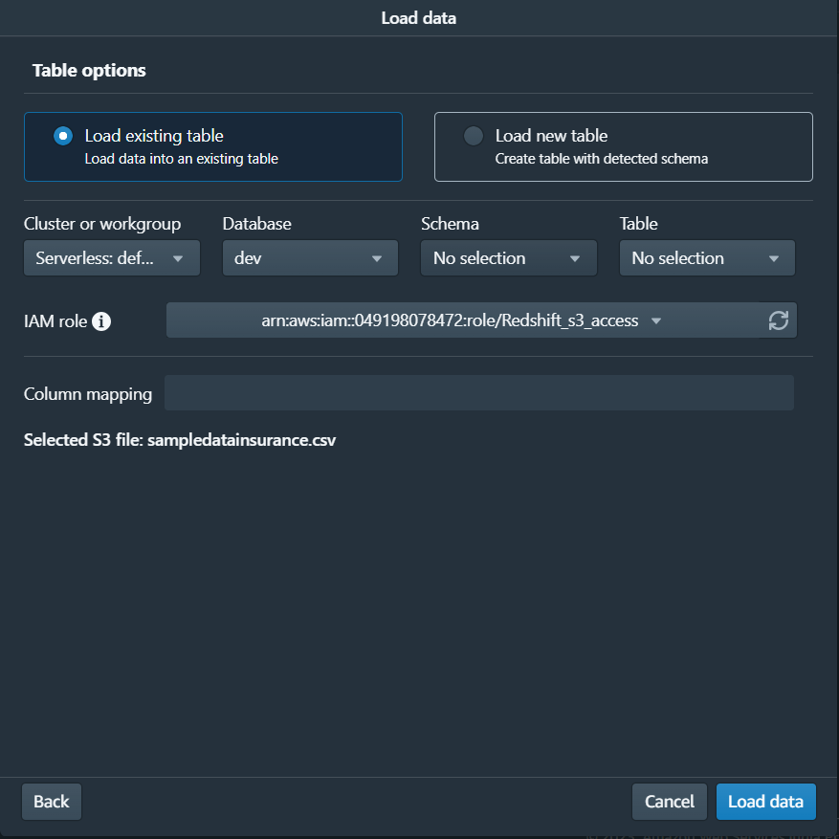

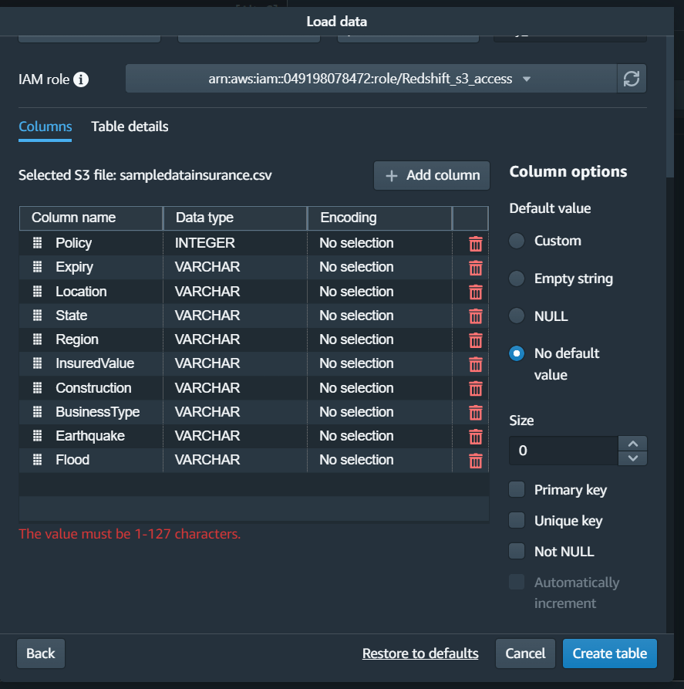

Unable to click on the create table and it is giving me the error “The value must be 1-127 characters.

